**----------------> about cloud computing:🡨--------------**

A cloud solution is not always better than an on-premise solution.

You can build and deploy custom AI models in the cloud.

A server in the cloud is a powerful computer that you can connect into remotely

An internet connection is necessary to access cloud services.

you have access to additional computer power instantly.

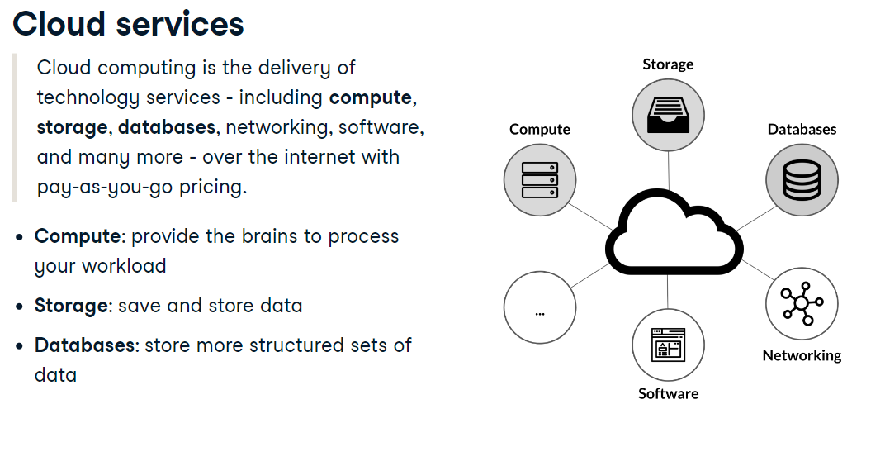

You can combine these three and other services to build different types of cloud solutions

**Characteristics of cloud computing:**

**1)scalability**

With cloud computing, you can easily add and remove resources as you need them

2) **Cost** :

only pay for resources when you are using them.

**3) Growth:**

Grow using a wide range of resources and services.

**4)security:**

It's important for companies to make sure that all data is securely stored or managed.

With the cloud computing you can easily access resources in multiple geographic region

**Deployment** : ka mtlb istemall ma lana .

**Infrastructure** : infrastruction is the physical system of the organization and often involves the production of public goods.

**Private cloud model:**

Private cloud model can get access all the data centers.

It is hosted by the organization own infrastructure. This model provide more security than public

Cloud model. The private cloud model can be manage by the organization

**Personal data:**

Personal data is any information that relates an identified living individual.

This include like eye color,face color, ip address, country, city, salary etc.

**Cloud architect :**

Cloud architect is the solution architect of the cloud.

Design cloud infrastructure base on business requirements.

**Flexible:**

Mean chage easily according to the satuation.

**Q : Why cloud computing is growing in popularity?**

1. Google Docs use cloud computing thus allowing several people to work on the same document in real time. Scalable, flexible and reliable: Scalability means unlimited processing and storage capacity.
2. Useful in application development
3. Automatic software updates.
4. If your server on the cloud then it can be accessed by the whole world.
5. By all the above advantages cloud computing are growing day to day.

**Activate:**

To start the functionality of a software application.

Or

Verify a software license.

Or

make (a device or system) operational.

**Microsoft azure provides the following services:**

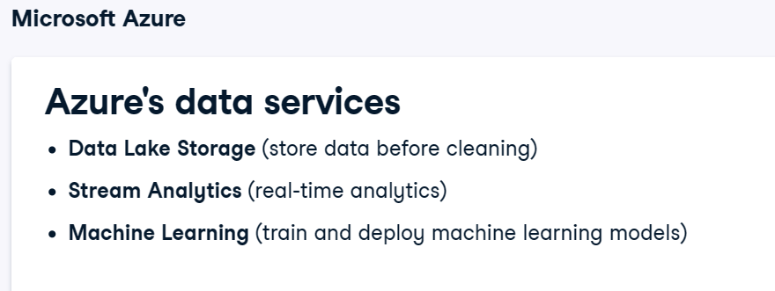

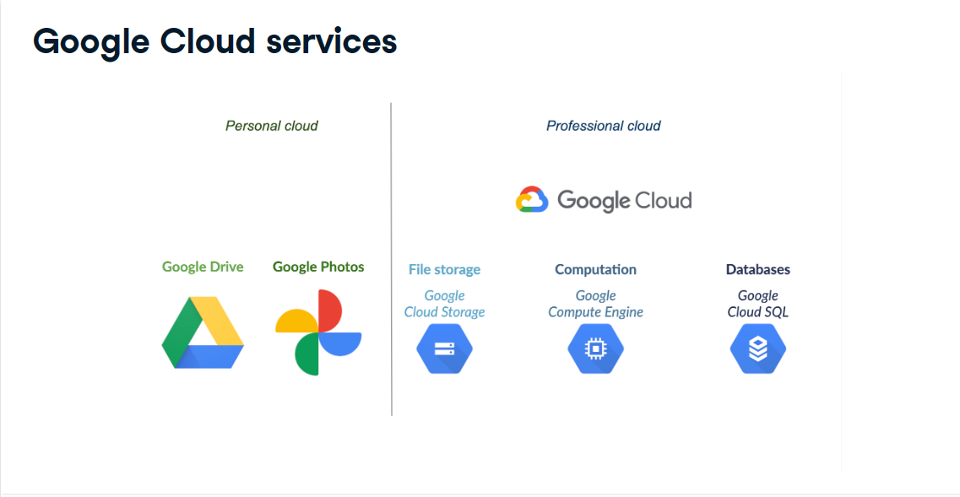

**Note:**

**If you want to improve scalability, availability of their e-commerce plate-form then**

**Migrate the entire infrastructure into the cloud computing. Basically cloud computing provides**

**By three company Microsoft ,google and amazon**.

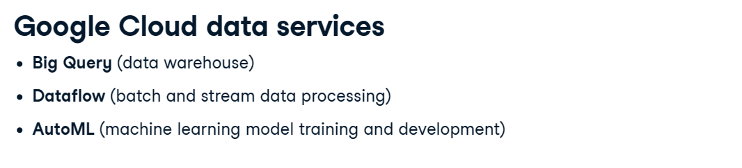

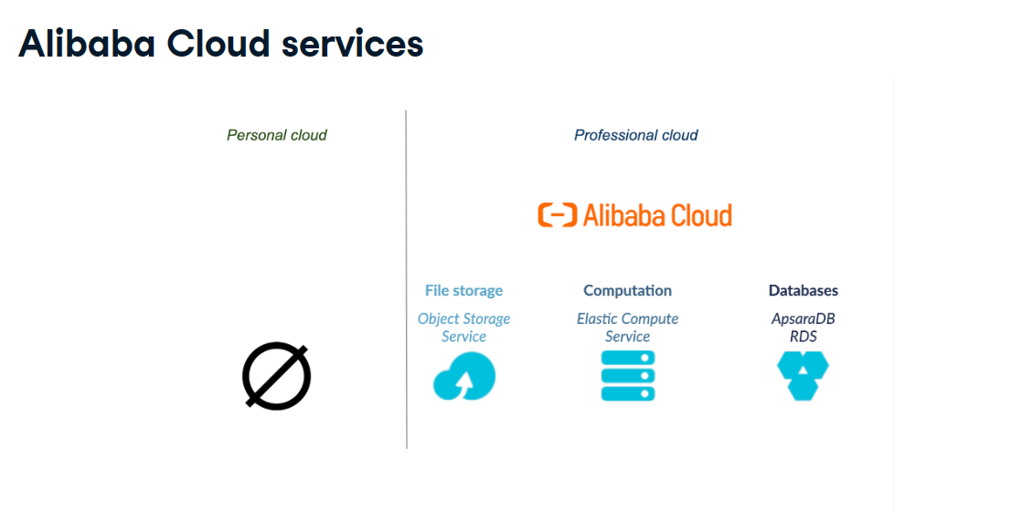

**Outage:**

It is a period when the power supply or other service is not available.

**General :**

We wanted to focus on deploying your own application to the cloud.

The best cloud provider is the one meeting your needs.

**Future of the cloud:**

In any case, the cloud has a bright future. The global amount of data generated is not slowing down (2.3 trillion gigabytes of data are created every day), and this data needs to be stored, processed and managed. Artificial intelligence needs more and more computing resources. If smart cities are the future, and the cloud will provide the underlying infrastructure as they develop. Last but not least, as developers want to quickly develop, test and deploy applications, serverless architectures (where managing the server and allocating resources is handled by the cloud) are becoming increasingly popular.